Title of the report
Subtitle
Julien Vitay
Fred Hamker
2024-06-21
Abstract
This is the abstract of the report. It can span multiple lines.
Table of contents

1. Introduction

1.1 First subsection
References: Scholl et al. (2022) showed that XXX (Vitay, 2017).
See Figure 1 and Section 3.
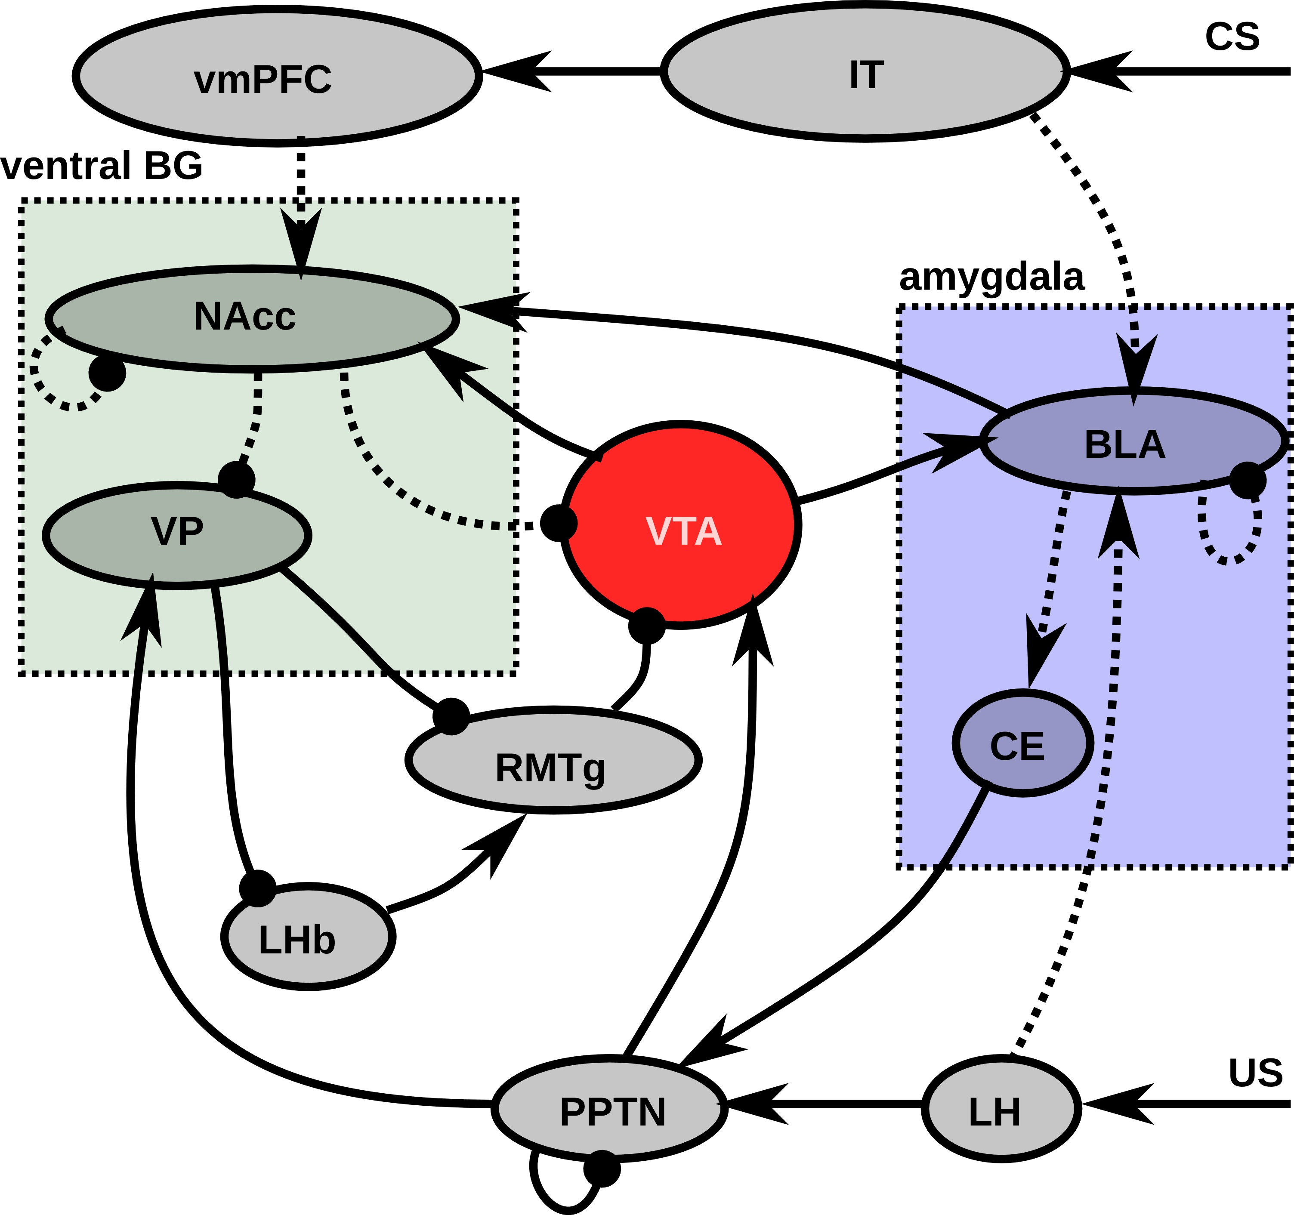
Figure 1: Afferent system to VTA. (Vitay, 2017)
Equations:
τ dxjtdt+xjt=i​wijin riint+g i≠j​wijrec rit
Admonitions:
 Nota Bene
Important information.
Code snippets:
for i in range(10):
print(i)

1.2 Second subsection
https://www.youtube.com/embed/tPgf_btTFlc

2. Material and methods

3. Results

4. Discussion

References
Scholl, C., Baladron, J., Vitay, J., and Hamker, F. H. (2022). Enhanced habit formation in Tourette patients explained by shortcut modulation in a hierarchical cortico-basal ganglia model. Brain Structure and Function. doi:10.1007/s00429-021-02446-x.
Vitay, J. (2017). On the role of dopamine in motivated behavior: A neuro-computational approach. Available at: https://julien-vitay.net/publication/vitay2017/.

